

Support to help you through the coronavirus outbreak
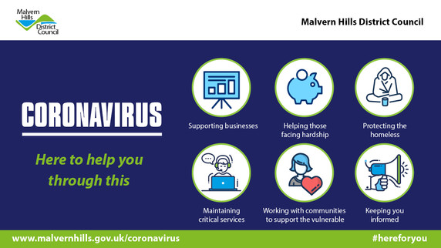
We continue to work with our colleagues in the NHS, Public Health and across local and national government to support you through the coronavirus outbreak.
Within this email is useful information on how our services are affected, financial support available for people and businesses, scam warnings, how to get help if you need it, things to do while you are at home and more.
Stay safe.

Support for individuals
If you are struggling financially then we would advise you to make a claim for Universal Credit, Council Tax Support and other benefits you may be eligible for.
You can check your eligibility at www.gov.uk/coronavirus and there is also more information on the Government’s Universal Credit and coronavirus page.

Help paying your Council Tax
Households currently receiving Council Tax Support and of working age will receive a one-off reduction of up to £150 on their Council Tax Bill as part of the Covid-19 (coronavirus) Council Tax Hardship Fund 2020-21. You do not need to apply for this funding, we will use the information we hold on our systems to make changes to your bills automatically.
If you do not qualify for support from the Hardship Fund, but are worried about paying your Council Tax bill, then we can still help.
You can apply online for Council Tax Support
You can also spread your payments over 12 months instead of ten. Just email us at revenues@southworcestershirerevenues.gov.uk to discuss.

Support for businesses
The Government has made a range of support available to businesses. Our latest business bulletin has details of all the support available.
We know the Government website and HMRC are informing businesses they will receive this support automatically but some of it does require companies to register. Please see the bulletin for full details and links to the application form.

Impact on our services
You can see a list of all our affected services here.

Waste and recycling
We have a plan in place to maintain our waste and recycling collections throughout the coronavirus outbreak. We will update our website and issue an email alert if there is any disruption. Please continue to put your bin out as usual by 7am on your normal collection day.
To support the crews we are asking you not to carry out any shed, house or garage clearances unless you have the ability to store any waste generated for a period of time. The Household Recycling Centres are closed and we cannot accept additional waste outside of the black bins as it would overwhelm the collection service.
We also remind you that if you or anyone within your household has symptoms of coronavirus, that used tissues and disposable cleaning cloths should be put in a rubbish bag. Then put the bag into a second bag and tie it securely. Store it for three days before putting it in your black bin.
If on a sack collection follow the same process and store bags separately from bags of standard household waste for three days. They can then be put out for collection together on your usual collection day.
You can dispose of other household waste as normal
We would also like to say thank you for all the messages of support (like the one below) and drawings you have been leaving for our bin crews. They really do appreciate it.
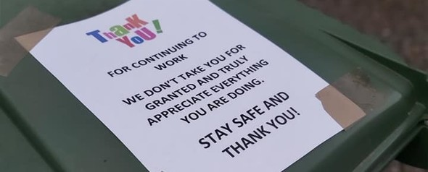

Parking
NHS and adult social care workers can park for free in our car parks and in on-street parking bays for as long as they need while on essential duties, as long as they display evidence of employment such as a photocopy of an ID badge with sensitive data removed.
Lots of people have been asking us why our Civil Enforcement Officers – commonly referred to as traffic wardens – are still working. The Government has asked us to continue carrying out traffic enforcement in the interest of public safety, to help key workers and emergency services continue their important work and allow important deliveries to continue to be made. Their focus is on ensuring people do not block loading bays, disabled bays, park dangerously or on double yellow lines etc.

Help for those in need
If you are in need of support and do not already have help from friends, family, the voluntary sector or adult social care then please fill in the form on the Worcestershire Here 2 Help website.
We have also produced a list of businesses delivering food.

Offers of help
If you want to help volunteer to deliver food and supplies to elderly and vulnerable people then please complete the Offer of Help form on the same website.

Looking after your health and well-being
It is okay to feel worried, anxious or stressed at the moment but it is important to look after both your physical and mental health while following the rules on social distancing.
A range of video workouts, advice and other information is available online to help you.
- NHS Every Mind Matters - Tips on how to take care of your mental health.
- Sport England Stay in, Work out - Advice on how to keep active around the home.
- Subscribe to our YouTube channel and follow us on Facebook (@MalvernHillsUK) and Twitter (@MalvernHills_DC).
- World Health Organisation - For advice and myth busters about the virus.
- Coping with stress document
- Anxiety Self Help information sheet
- Helping children cope with stress document
If you need help explaining about the virus and what is happening to your children then please download this information sheet from the children’s commissioner.

Be on your guard against scams
There are lots of scams connected to coronavirus circulating at the moment. Some involve fake calls, texts, emails and social media messages. West Mercia Police have issued advice on how to avoid becoming a victim of a coronavirus scam.
The Insolvency Service and the Financial Conduct Authority are also warning the public to be extra vigilant and be wary of scams related to coronavirus that target finances.
Action Fraud is also warning about a Home Testing Fraud.
Social workers are also reporting a number of suspicious volunteers targeting vulnerable people in the county. Worcestershire County Council's advice is to take normal precautions but don’t be afraid to accept offers of help from those you know and trust.
We are reminding people to follow normal checks to make sure their volunteer helpers are genuine. We advise people to ask to see identification, and not allow anyone in their homes unless they are certain they are genuine. Anyone who believes they have been visited by a bogus volunteer should contact the police.

Beware of false information
A new GOV.UK WhatsApp Coronavirus Information Service has now been launched. The purpose of this product is to combat the spread of misinformation. To use the service, you simply add +44 7860 064422 to your contacts and send a WhatsApp message saying “Hi”.

Things to do at home
A number of cultural organisations have created virtual tours or are making their content available online for people to enjoy from home.
The National Gallery Virtual Tour
The British Museum Virtual Tour
Sadler's Wells Digital Stage
National Theatre at Home
Royal Opera House Programme
We've also put together a list of ideas for young people to try while at home.

Stay at home and save lives
By staying home, you are helping to reduce the spread of the virus and giving our NHS workers the best chance of saving as many lives as possible. As the national lockdown continues and with the weather warming up, it is easy to become complacent and become tempted to ignore social distancing rules. Please don’t the next couple of weeks will be crucial in our battle against the virus. So please, stay home, protect the NHS and save lives..
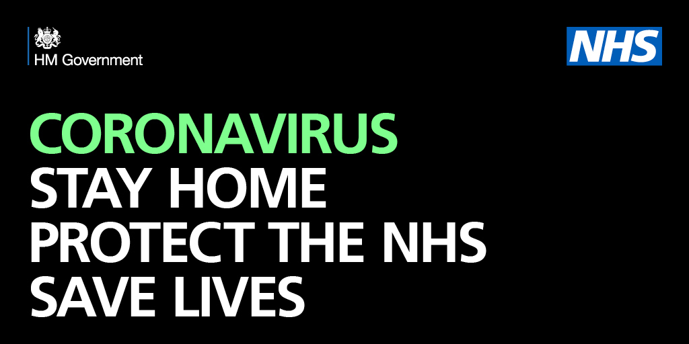

A reminder of the social distancing rules
The Cabinet Office has also produced a dos and don’ts FAQs list

Update your subscriptions, modify your password or email address, or stop subscriptions at any time on your Subscriber Preferences Page. You will need to use your email address to log in. If you have questions or problems with the subscription service, please visit subscriberhelp.govdeliverycom.
This service is provided to you at no charge by Malvern Hills District Council.
This email was sent to john.sharp@btinternet.com using GovDelivery Communications Cloud on behalf of: Malvern Hills District Council · Council House · Avenue Road · Malvern · WR14 3AF

