Safer Neighbourhood Team Newsletter:
Malvern and Upton
Issue 3 - Bringing you updates from your local teams | 1 April 2022 to 30 June 2022

In this edition …

A few changes to your SNT…

- The past three months have been an incredibly busy time for the team in terms of operational policing and there have been some personnel changes.

The Kempsey & Alfrick team have said goodbye to PCSO Faye Allen-Carter who has embarked on a career as a Problem Solving Officer with Malvern Hills District Council. She has been replaced by PCSO Brandon Knight who moves from the Pickersleigh team. PCSO Knight has been (and will be) visiting as much of the community as he can and over the next few weeks will be getting to know you all.

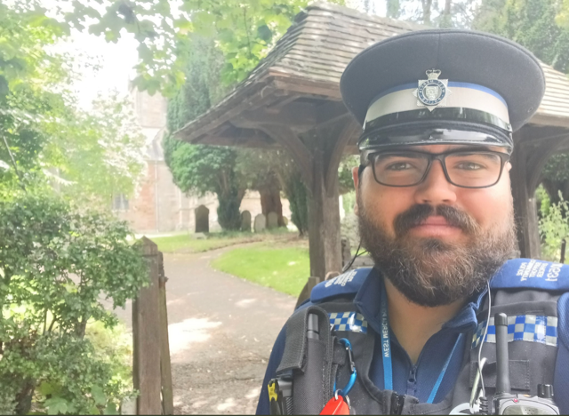

There may well be some further incomings and outgoings within the team due to some of the PC’s seeking promotion. Any changes should be settled by mid to late July so as soon as they are, new team posters will be distributed to each Parish Council.

Is speeding traffic affecting the quality of life in your community?…

- Community Speed Watch Programme
In the Local Policing Charter contracts we receive from Parish Councils, almost all returned identify speeding as a policing issue they wish for the Safer Neighbourhood Team to treat as a priority. With that, Malvern & Upton Safer Neighbourhood Team are looking to generate Community Speed Watch groups across our policing area.

Community Speed Watch is a community driven road safety initiative, coordinated by West Mercia Police but managed and run by volunteers in the community. It has now been running for 8 years in West Mercia and we’re reminding local residents about the scheme and how you can get involved as a volunteer if speeding traffic is causing concern.

The scheme involves trained volunteers monitoring the speeds of vehicles with approved, hand-held speed measurement devices. Where vehicle speeds are found to be inappropriate, a letter is sent to the registered keeper by the police with the aim of encouraging them to reduce their speed when driving in the future.

A Community Speed Watch scheme is initiated when ‘speeding traffic’ has been identified as a community road safety concern by a parish council. Therefore, it’s important to raise any concerns about speeding traffic to your local parish council in the first instance.

In areas where community concerns about speeding are raised, speed data will be collected by West Mercia Police to determine the nature of the problem and action will be taken accordingly.

To find out more, including the criteria that must be met before a Community Speed Watch scheme can be established, visit: https://www.westmercia.police.uk/news/west-mercia/news/2022/february/could-you-make-a-difference-to-the-safety-of-the-roads-in-your-community/
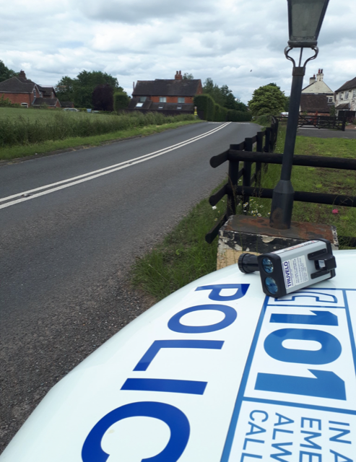

Working hard to serve the community…

- The Malvern and Upton teams have been exceptionally busy in running various national and local operations, targeting vehicle crime, speeding, local anti-social behaviour and modern day slavery. We have also been in attendance at various community engagement functions which have included The Three Counties Show and Jubilee events.

- Cycle patrols to great effect
In the last newsletter, I spoke of Op Close Pass which is a policing operation that has brought some very positive feedback from the community. It specifically targets road users whose actions pose a danger to others; cyclists in particular.

Therefore, we have sought to increase the activity across the whole of the policing area and some of our more rural locations will have seen officers patrolling more on push bikes. Not only has this allowed us to ensure safer roads, but it has also allowed us to reach a wider audience and engage more effectively than we would if we were patrolling in vehicles.

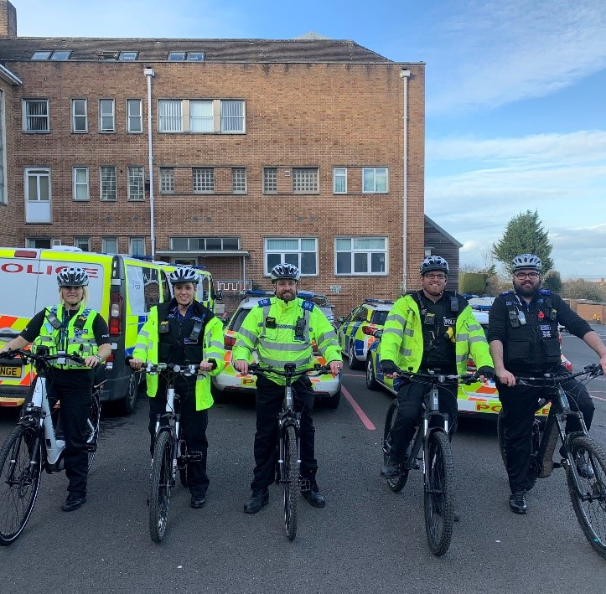

The use of cycles has allowed us to patrol hotspots for alcohol and drug related anti-social behaviour. The PCSO’s in particular have had this as a patrol strategy across the area and we have seen a reduction in the incidents of anti-social behaviour recorded and further seizures of alcohol amongst youths.

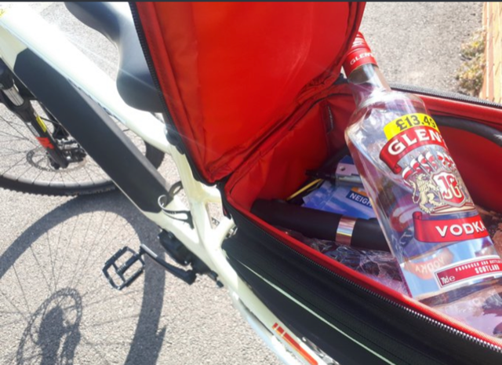

This patrol strategy will continue throughout the summer months.

- Vehicle Crime
We held a very successful multi-agency events on the A449 at Bastonford where we were partnered by Malvern Hills District Council (MHDC), Driver and Vehicle Standards Agency (DVSA – formerly VOSA) and H&M Revenue and Customs (HMRC).

Criminals use the roads across the country to further their criminal activity and so we run operations such as this to target vehicles and use enforcement where we can.

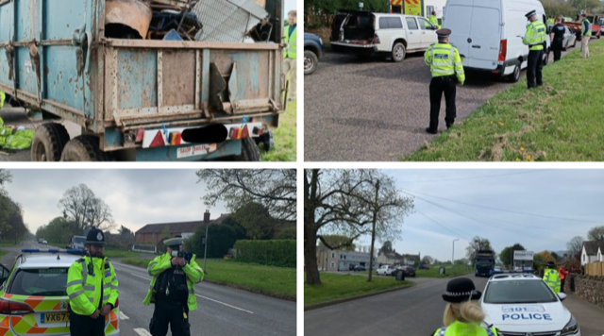

Throughout the operation, police conducted speed enforcement and stopped vehicles with intelligence markers for being used in crime and where waste carriage matters or vehicles defects were considered.

In total, 74 tickets were issued across the area for speeding offences, six vehicles were issued with notices condemning the vehicle and one driver was fined for being found to be using cherry diesel in a private vehicle.

We will be continuing to run these multi-agency operations throughout the year.

- Human Trafficking and Modern Day Slavery
Malvern & Upton SNT ran a successful operation as part of a national campaign run by The National Crime Agency with the purpose of the visits to premises being to engage with staff and management in regard to trafficking and slavery matters. Operations look at targeting those involved in Human Trafficking & Modern Day Slavery which is an issue that has been in the news recently.

We attended a number of different business premises across our policing area and engaged with staff and management on a voluntary basis and were pleased to see that level of cooperation. Our visits, which look at everything from working conditions to living conditions are also carried out with the support of colleagues from areas such as housing who make sure anyone who lives on site does so under the laws designed to protect them.

There were arrests made at two of the premises for matters not relating to trafficking or slavery, but given the nature of our work, we often locate individuals who are involved in crime or wanted on unrelated issues. This is often the case in policing where offences not relating to the purpose of an operation are discovered and understandably we respond appropriately.

- Nottingham Knockers
We experienced a sudden influx of Nottingham Knockers to the area and I am pleased to report a swift response meant that they soon left the area.
Nottingham Knockers are groups of persons who visit homes – often of those elderly or considered vulnerable – and sell household items for often hugely inflated prices. They are unlicensed and often employ hassling and aggressive tactics to secure a sale. Reports of lone elderly residents paying in excess of £20 for a pack of two dusters is not uncommon so we as a team are keen to strike quickly to ensure we keep the community safe from this.

The prompt reporting by concerned members of the public and swift actions of officers enabled us to establish that they were operating without the required pedlar’s certificate and goods were seized from those individuals who were reported for summons.

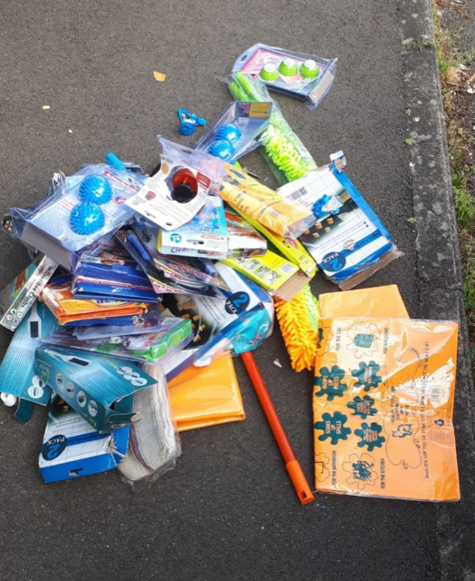

Please urge your communities to be vigilant and report suspicious behaviours to the police.
- Engagement in Local Events
Our engagement calendars have been full with festivals, fetes, surgeries, crime prevention workshops and school events.

The Three Counties Show:

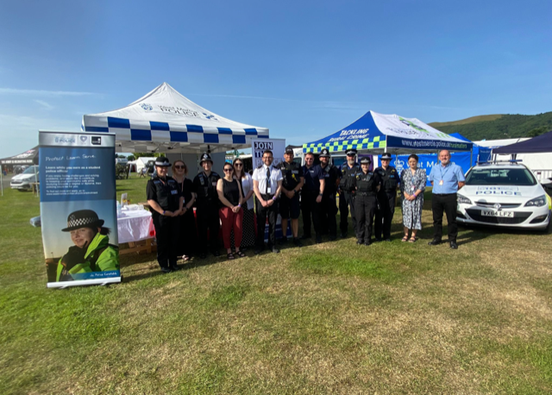

The Spring Festival in Malvern:
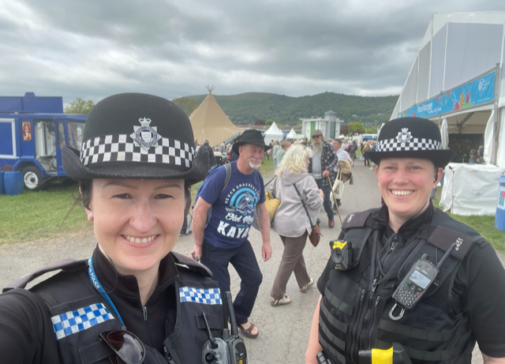

Crime prevention workshops:
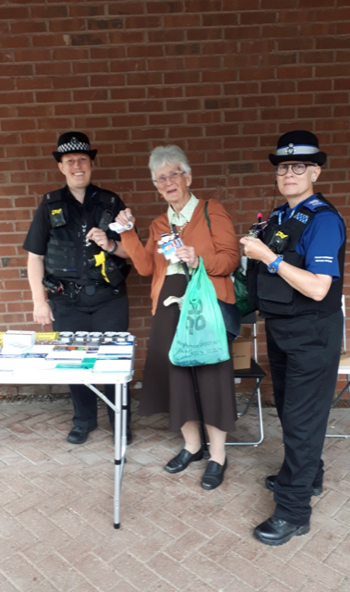

Community safety focus…

- Anti-social behaviour in open areas
We have received numerous reports regarding anti-social behaviour where dirt bikes/quad bikes and scooters have been used on land other than a road.

We have adapted our patrol strategies accordingly and we urge the community to work with us in providing evidence so we can seek prosecutions. I accept residents may be concerned about being involved in the evidential chain, but it is imperative we can provide such evidence to take positive action. Please, if any residents raise these issues, urge them to engage with us and allow us to be positive.

The below motorcycle was seized and destroyed. It is an example of where the community have informed us of incidents and provided evidence where we have been able to specifically target our patrols and take positive action.

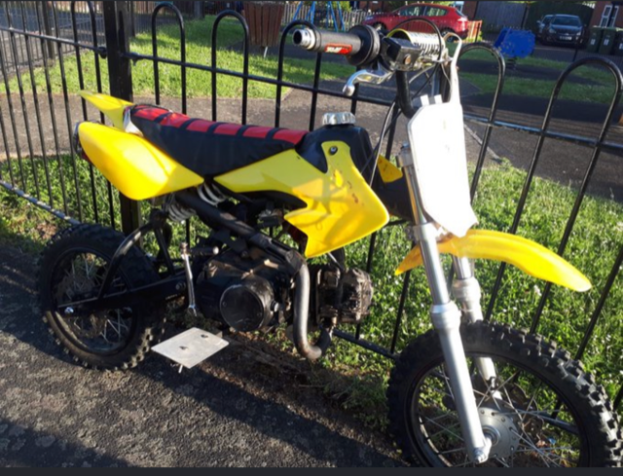

- Open Water Swimming
With the schools about to end their academic year and embark on their summer holidays, it is a timely reminder of the dangers of swimming in open water.

Rivers, lakes and quarries form part of our policing area and all have inherent dangers.

Gullet Quarry in Castlemorton is an area we patrol regularly due to the fact we have members of the public forcing their way in through the fences and swim in the waters.

The danger of the quarry is well known; very deep and freezing cold water, items dumped in the quarry causing underwater hazards and a lack of supervision should people get into difficulty. There have been fatalities and those found in the quarry will be subject to fines.

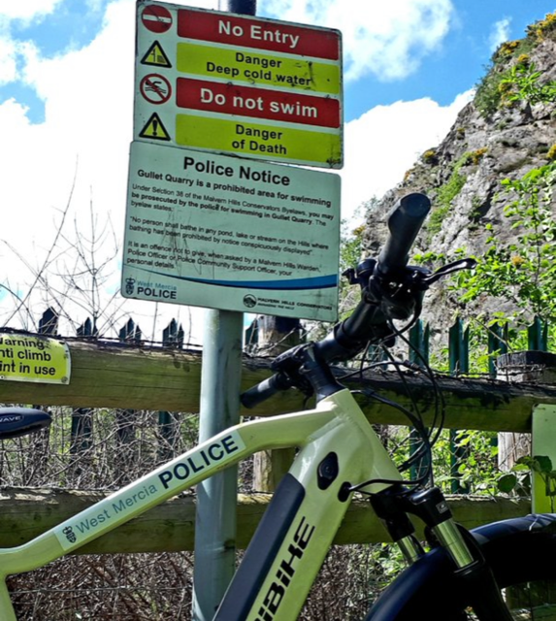

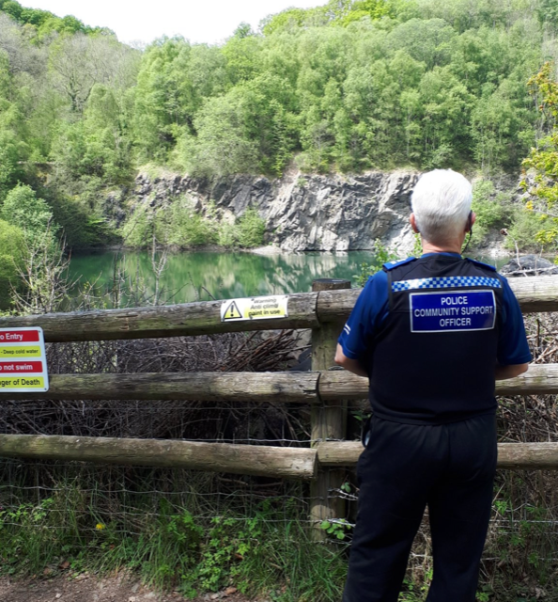

The dangers of open water swimming are very clear so please, help us to reinforce this message throughout your communities – stay out of open water.

A push to parishioners…

- Previously, we have been advertising the benefits of the Neighbourhood Matters system. I make no apologies in continuing to push this because of the benefits it brings the community and the feedback on offer to the work we are doing within each of your communities.
This is a free service available to all and it is where West Mercia Police will provide community messages, crime prevention advice and details of community engagements.
You can sign up to receive messages via this link https://neighbourhoodmatters.co.uk/ and we would be grateful if you could push this message to your respective parishes.



Upcoming events…
- Please look out for the dates advertised on Neighbourhood Matters, Twitter and Facebook.

Keep in contact with your SNT…
- Email the teams:
Pickersleigh
pickersleigh.snt@westmercia.pnn.police.uk

Link and Dyson linkanddyson.snt@westmercia.pnn.police.uk

Kempsey and Alfrick ka.snt@westmercia.pnn.police.uk

Priory and Wells
chaseandpriory.snt@westmercia.pnn.police.uk

Upton
upton.snt@westmercia.pnn.police.uk

- Twitter: @MalvernCops
- Facebook: ‘Malvern Cops’

- For crimes in progress call 999.
- For non-emergencies report online: https://www.westmercia.police.uk/

